Home Automation Using Android

This project helps to control the electrical loads with the help of android application. The electrical loads are controlled based on Bluetooth input signal. This input signal is received from the android device. Many times it becomes too tiring to operate the electrical switches manually every now and then. This is a big problem especially in case of aged or handicapped people.
This system solves the issue by interfacing a unit with home appliances that switches these loads based on the input received from android device.
The android device may be any android based phone or tab having an android OS. The app also provides an effective GUI for providing this functionality.
An 8051 microcontroller is used in this system. The Bluetooth receiver is interfaced with microcontroller in order to accept the commands and then react accordingly. It operates the loads through a set of relays using a relay driver IC. Relays are used between loads and the control unit.
This system proves to be very beneficial for controlling various domestic applications and in industrial setups. The power supply setup of the system contains a step down transformer of 230/12V, used to step down the voltage to 12VAC. To convert it to DC, a bridge rectifier is used. In order to remove the ripples, a capacitive filter is used and it makes use of 7805 voltage regulator to regulate it to +5V that will be needed for microcontroller and other components operation.

Block Diagram:

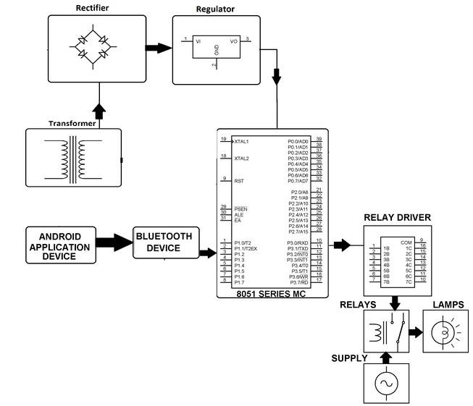

Hardware Specifications

- 8051 series Microcontroller
- Bluetooth device
- Diodes
- Relays
- Voltage Regulator
- Crystal
- LED
- Relay Driver IC
- Transformer
- Lamps

Software Specifications

- Keil µVision IDE
- MC Programming Language: Embedded C

